Basic Rules for Klin Zha

Object of the game.

The object of Klin Zha is to capture your opponent's goal or make it impossible for your opponent to move legally.

Description of the board and pieces.
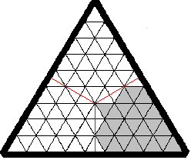
The board is triangular, marked with a triangular grid of nine triangles per side, giving a total of
eighty-one playing spaces.
There is an additional division of the board which is not visible, but is merely understood. That is the division of the playing area into three corners, or points. Each player arranges his or her pieces within one of the board's points. Action extends out over the full board as play proceeds.
The half-spaces of each point are not available for piece placement, representing a sort of no-man's-land between opposing sides.
Playing pieces may be carved or formed from materials into recognizable shapes or simple disks marked with the symbols of the pieces. There are nine pieces and one Goal per side; the traditional colors for each side being green and gold. The pieces include 1 Fencer, 1 Lancer, 1 Swift, 2 Fliers, 3 Vanguards, 1 Blockader and the Goal, the very important non-piece.
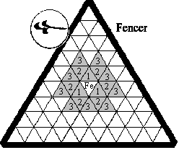
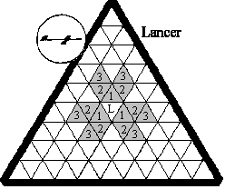
Characteristics of the pieces.

Fencer (1). Moves 1, 2 or 3 unobstructed spaces in any direction and combination.
Lancer (1). Moves 1, 2 or 3 unobstructed spaces straight in any direction.
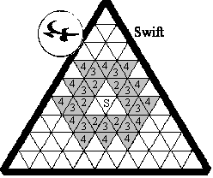
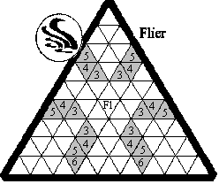
Swift (1). Moves 2, 3 or 4 unobstructed spaces in any direction or combination. It cannot carry the Goal.
Fliers (2). Move 3, 4, 5 or 6 spaces straight in any direction. Can jump over other pieces including those protected by the Blockader. It cannot carry the Goal.
Vanguards (3). Move 1 unobstructed space in any direction.
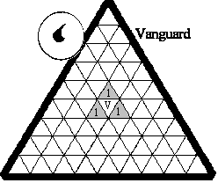
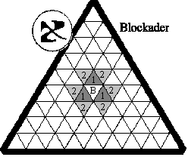
Blockader (1). Moves 1 or 2 unobstructed spaces in any direction. Cannot carry the goal, kill another piece or be killed. Opposing pieces cannot enter any adjoining space nor can the Blockader move into a space occupied by or adjoining an opposing piece. Opposing Blockader zones of control cannot overlap. The player's Goal cannot end its movement within the Blockader's zone of control but the Blockader is capable of capturing an opponent's unattended Goal.

Goal (1). The goal cannot move by itself. It can be carried about by a warrior or even abandoned on a space by a piece that moves away, but it cannot be endangered intentionally. It is to be captured by an opponent. When left unattended on a space, the Goal does not pose an obstruction to the movement of the warrior pieces.
The Goal cannot be carried by the far-ranging attack soldiers, the Swift or Flyers. Neither can it be carried within the protection of the Blockader. Again, that would make it impossible to capture from a gaming standpoint. The goal can be moved with a Carrier piece through the blockader's zone-of-control on its way to its destination.

The Manner of Play

A random decision is made (throw of dice, flip of coin, etc). The winner of the throw may grant the option to "choose first position" to his opponent or not. To set up first reveals your thoughts and is a disadvantage.
First one side sets up his or her entire set of pieces in any arrangement within one of the "points" of the board. Then the other player does the same within one of the two remaining points, leaving the third point open. After both sides have placed their pieces, the Goals are placed with "carrier" pieces.
The color with the first placement moves first.
Pieces move on the triangles, side-to-side, rather than point-to-point.
Opponent's pieces are removed from play by landing on the space that they occupy at the end of the attacker's movement.
It is illegal to make any move that endangers your own Goal.
Play proceeds until one player's Goal is either captured or cannot make a legal move.

Rules for the game Klin Zha Copyright © 1989 by Leonard B. Loyd, Jr.
Presented by The Authorized Klin Zha Homepage at http://www.fyi.net/~kordite/klinzha.htm

